Q9. Design a DFA in LEX Code which accepts string containing even number of ‘a’ and even number of ‘b’ over input alphabet {a, b}.

Code:

%{
%}

%s A B

%%
<INITIAL>a BEGIN INITIAL;
<INITIAL>b BEGIN A;
<INITIAL>[^0|\n] BEGIN B;
<INITIAL>\n BEGIN INITIAL; printf("Accepted\n");
<A>a BEGIN A;
<A>b BEGIN INITIAL;
<A>[^0|\n] BEGIN B;
<A>\n BEGIN INITIAL; printf("Not Accepted\n");
<B>b BEGIN B;
<B>a BEGIN B;
<B>[^0|\n] BEGIN B;
<B>\n {BEGIN INITIAL; printf("INVALID\n");}
%%

voidmain()
{
yylex();
}

Output:
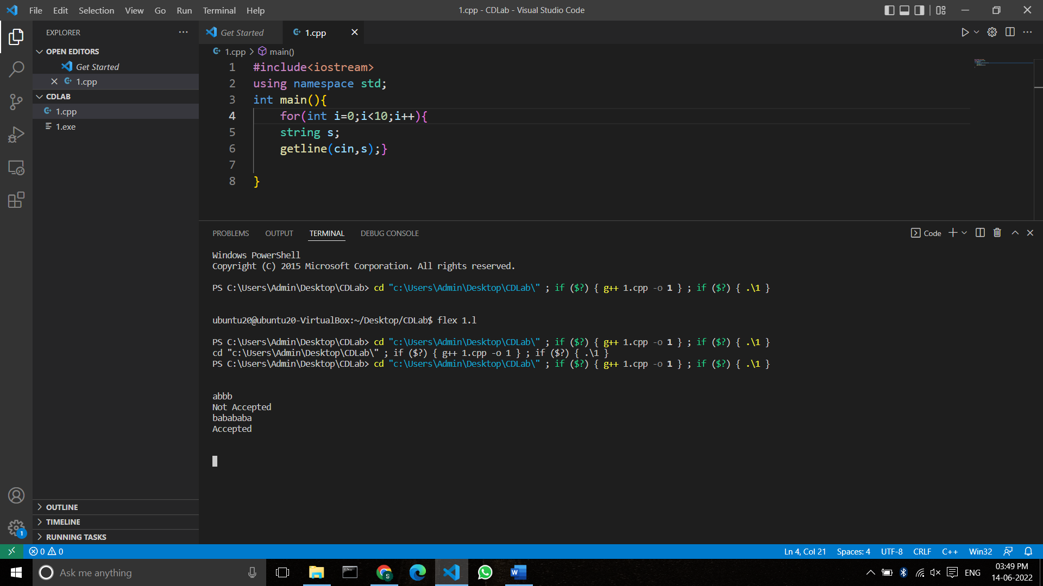

Q10. Design a DFA in LEX Code which accepts string containing third last element ‘a’ over input alphabet {a, b}.

Code:

%{
%}
%s A B C D E F G DEAD
%%
<INITIAL>b BEGIN INITIAL;
<INITIAL>a BEGIN A;
<INITIAL>[^ab\n] BEGIN DEAD;
<INITIAL>\n BEGIN INITIAL; {printf("Not Accepted\n");}

<A>b BEGIN F;
<A>a BEGIN B;
<A>[^ab\n] BEGIN DEAD;
<A>\n BEGIN INITIAL; {printf("Not Accepted\n");}

<B>b BEGIN D;
<B>a BEGIN C;
<B>[^ab\n] BEGIN DEAD;
<B>\n BEGIN INITIAL; {printf("Not Accepted\n");}

<C>b BEGIN D;
<C>a BEGIN C;
<C>[^ab\n] BEGIN DEAD;
<C>\n BEGIN INITIAL; {printf("Accepted\n");}

<D>b BEGIN G;
<D>a BEGIN E;
<D>[^ab\n] BEGIN DEAD;
<D>\n BEGIN INITIAL; {printf("Accepted\n");}

<E>b BEGIN F;
<E>a BEGIN B;
<E>[^ab\n] BEGIN DEAD;
<E>\n BEGIN INITIAL; {printf("Accepted\n");}

<F>b BEGIN G;
<F>a BEGIN E;
<F>[^ab\n] BEGIN DEAD;
<F>\n BEGIN INITIAL; {printf("Not Accepted\n");}

<G>b BEGIN INITIAL;
<G>a BEGIN A;
<G>[^ab\n] BEGIN DEAD;
<G>\n BEGIN INITIAL; {printf("Accepted\n");}

<DEAD>[^\n] BEGIN DEAD;
<DEAD>\n BEGIN INITIAL; {printf("Invalid\n");}

%%
int yywrap()
{
return 1;
}
int main()
{
printf("Enter String\n");
yylex();
return 0;
}

Output:

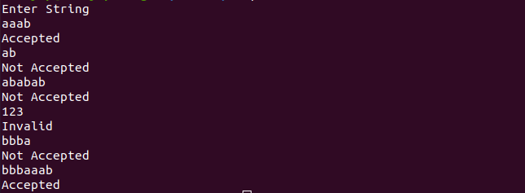

Q11. Design a DFA in LEX Code for string ending with “11”.
Code:

%{
%}
%s A B DEAD

%%
<INITIAL>1 BEGIN A;
<INITIAL>0 BEGIN INITIAL;
<INITIAL>[^01\n] BEGIN DEAD;
<INITIAL>\n BEGIN INITIAL; {printf("Not Accepted\n");}

<A>1 BEGIN B;
<A>0 BEGIN INITIAL;
<A>[^01\n] BEGIN DEAD;
<A>\n BEGIN INITIAL; {printf("Not Accepted\n");}

<B>1 BEGIN B;
<B>0 BEGIN INITIAL;
<B>[^01\n] BEGIN DEAD;
<B>\n BEGIN INITIAL; {printf("Accepted\n");}

<DEAD>[^\n] BEGIN DEAD;
<DEAD>\n BEGIN INITIAL; {printf("Invalid\n");}

%%

intmain()
{
printf("Enter String\n");
yylex();
return0;
}

Output:

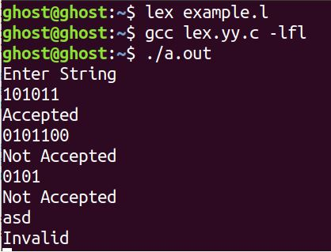

Q12. Design a DFA in LEX Code which accepts string having even number of ‘a’ over input alphabet {a,b}.
Code:

%{
%}

%s A DEAD

%%
<INITIAL>a BEGIN A;
<INITIAL>b BEGIN INITIAL;
<INITIAL>[^ab\n] BEGIN DEAD;
<INITIAL>\n BEGIN INITIAL; {printf("Accepted\n");}

<A>a BEGIN INITIAL;
<A>b BEGIN A;
<A>[^ab\n] BEGIN DEAD;
<A>\n BEGIN INITIAL; {printf("Not Accepted\n");}

<DEAD>[^\n] BEGIN DEAD;
<DEAD>\n BEGIN INITIAL; {printf("Invalid\n");}

%%

int yywrap()
{
return 1;
}
int main()
{
printf("Enter String\n");
yylex();
return 0;
}

Output:

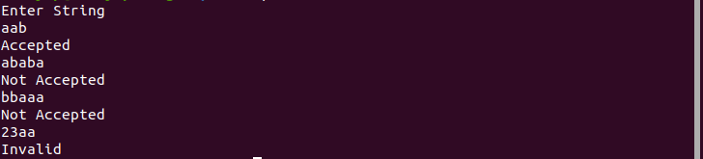

Q13. Design a DFA in LEX Code which accepts string containing odd number of 0 and even number of 1.

Code:

%{
%}

%s A B C DEAD

%%
<INITIAL>1 BEGIN A;
<INITIAL>0 BEGIN B;
<INITIAL>[^01\n] BEGIN DEAD;
<INITIAL>\n BEGIN INITIAL; {printf("Not Accepted\n");}

<A>1 BEGIN INITIAL;
<A>0 BEGIN C;
<A>[^01\n] BEGIN DEAD;
<A>\n BEGIN INITIAL; {printf("Not Accepted\n");}

<B>1 BEGIN C;
<B>0 BEGIN INITIAL;
<B>[^01\n] BEGIN DEAD;
<B>\n BEGIN INITIAL; {printf("Accepted\n");}

<C>1 BEGIN B;
<C>0 BEGIN A;
<C>[^01\n] BEGIN DEAD;
<C>\n BEGIN INITIAL; {printf("Not Accepted\n");}

<DEAD>[^\n] BEGIN DEAD;
<DEAD>\n BEGIN INITIAL; {printf("Invalid\n");}

%%

int main()
{
printf("Enter String\n");
yylex();
return 0;
}

Output:

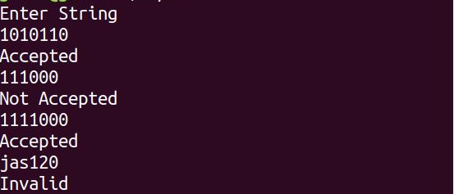

Q14. Design a DFA in LEX Code to Identify and print Integer & Float Constants and Identifier.

Code:

%{
%}

%s A B C DEAD

%%
<INITIAL>[0-9]+ BEGIN A;
<INITIAL>[0-9]+[.][0-9]+ BEGIN B;
<INITIAL>[A-Za-z_][A-Za-z0-9_]* BEGIN C;
<INITIAL>[^\n] BEGIN DEAD;
<INITIAL>\n BEGIN INITIAL; {printf("Not Accepted\n");}

<A>[^\n] BEGIN DEAD;
<A>\n BEGIN INITIAL; {printf("Integer\n");}

<B>[^\n] BEGIN DEAD;
<B>\n BEGIN INITIAL; {printf("Float\n");}

<C>[^\n] BEGIN DEAD;
<C>\n BEGIN INITIAL; {printf("Identifier\n");}

<DEAD>[^\n] BEGIN DEAD;
<DEAD>\n BEGIN INITIAL; {printf("Invalid\n");}

%%

intyywrap()
{
return1;
}

intmain()
{
printf("Enter String\n");
yylex();
return0;
}

Output:

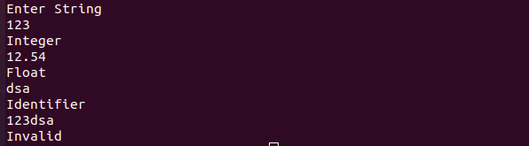

Ques 15Design Desk Calculator using YACC/LEX code.
Program: LEX:
%{

#include<stdio.h> #include "y.tab.h" extern int yylval;
%}

%%
[0-9]+ {
yylval=atoi(yytext); return NUMBER;
}
[\t] ;
[\n] return 0;
. return yytext[0];

%%
int yywrap()
{ return 1;

}

YACC:
%{
#include<stdio.h> int flag=0;
%}
%token NUMBER
%left '+' '-'
%left '*' '/' '%'
%left '(' ')'
%%

ArithmeticExpression: E{ printf("\nResult=%d\n",$$); return 0;
};
E:E'+'E {$$=$1+$3;}
|E'-'E {$$=$1-$3;}

|E'*'E {$$=$1*$3;}
|E'/'E {$$=$1/$3;}
|E'%'E {$$=$1%$3;}
|'('E')' {$$=$2;}
| NUMBER {$$=$1;}
;
%%
void main() {

printf("\nEnter Any Arithmetic Expression which can have operations Addition, Subtraction, Multiplication, Divison, Modulus and Round brackets:\n"); yyparse(); if(flag==0) printf("\nEntered arithmetic expression is Valid\n\n");
} void yyerror()
{ printf("\nEntered arithmetic expression is Invalid\n\n"); flag=1;
}

Output:
